**Practical-6:** Variants with reusable components

**Definition:** Use vector mode to edit and customize vector shapes and design different icons, and make reusable components of its vector using variants.

**Solution:**

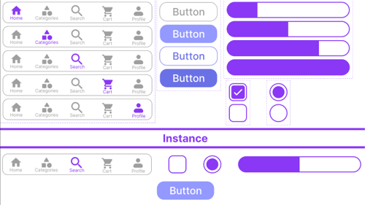

**Working:**

* First, open Figma. Add a new Figma design file.
* Rename a file as 124_Practical-6_Componet.
* In this design, the following tools are used for a particular operation:

|  |  |  |
| --- | --- | --- |
| Tools Name | Use | Properties |
| Frame Tool | Used as a container. Layer renamed to “MacBook Pro 16” - 1. | Width: 1728px, Height: 1117px,  Color fill: #000000 |
| Button | Rectangle + Text. Component created with variants. | Width: 156px, Height: 44px, Radius: 20px,  Colors: #DDE1EA, #4966FA, #174BFF, #063EBD |
| Bottom Navigation Bar | Rectangle + Icons from Iconify. One icon changes color in each variant. | Width: 421px, Height: 80px, Radius: 15px,  Icon Color: #7949FF |
| Toggle Controls | Simulates on/off button with slider and ellipse. Created with variants. | Size: 150x80,  Inner Rect: 80x30, Ellipse: 24x24, Color: #D9D9D9 |
| Check Box | Rectangle inside rectangle to simulate checkbox with text. | Size: 150x80,  Inner Rect: 25x25,  Text Box: 54x23 |
| Multiple-choice Circles | Ellipse inside rectangle to simulate options. | Size: 150x80, Ellipse: 44x44, TextBox: 24x31 |
| Progress Slider | Five rectangles colored to show levels. Created as component with variants. | Size: 117x17, Radius: 10px, Color: #7949FF |

* Export your design as a PNG file.